**EE 256: POWER AND ENERGY**

**Experiment: Power Factor Improvement**

(3 hours)

**DATE**: ....................................

**CAUTION: High voltages are present in this Laboratory Experiment! Do not make any connections when the power is on. The power should be turned off after completing each set of measurements**.

# INTRODUCTION

The course EE256 - Power and Energy contains sections of (i) Three phase Systems, (ii) Measurement of Power/Energy, (iii) Tariff and Demand Side Management sections. This experiment covers power measurement of single-phase system and power factor improvement with a capacitor.

# LEARNING OUTCOMES:

* LO 2: Discuss and demonstrate different methods of power measurements (covering attributes of WAl and WA2)
* LO 5: Calculate the power factor correction capacitors required for different applications (covering attributes of WA1 and WA2)

# OBJECTIVES:

To understand

1. the load voltage and current waveform patterns for different types of loads (LO2)
2. power factor improvement with fixed capacitors (LO 5)

# APPARATUS:

 Single Phase Transformer: 220V/110V

 Single Phase Wattmeter: 5A, 240V (YOKOGAWA)  AC Ammeter: 0 SA (YOKOGAWA)

 AC Voltmeter: 0 300V (YOKOGAWA) & 0-150V (YOKOGAWA)

 Variable resistor: 1H/13A  Variable AC Supply

 Digital Oscilloscope

 Resistive Load: 330a/2A.

 Variable Capacitor: (Terco MV1102)

 Variable Inductor: (ITALTEC or Terco MV1102)

TMEORY

1. Power factor calculation using meter readings

Ammeter (I) Wattmeter (P)

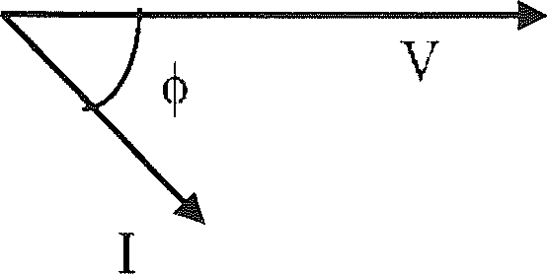115V,AC

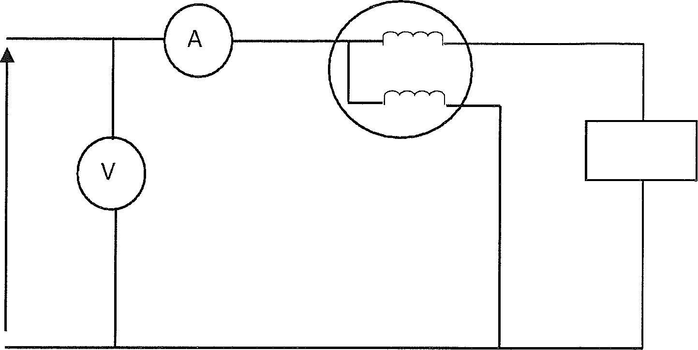

Load

Voltmeter (V)

1. Meter connections

Consider Figure 01. Active Power P,

P= V×I×cosφ Power Factor = P

(V×l)

Figure 1. Power factor calculation

1. Phasor diagram
2. Power factor calculation using wave forms

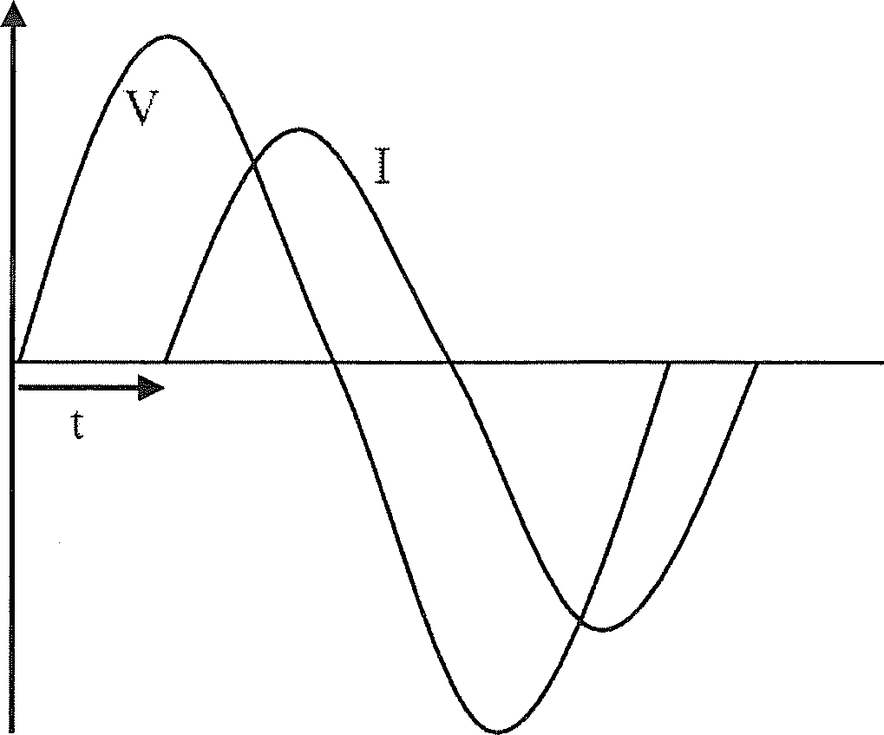

Figure 2: Voltage and Current Waveforms

Consider Figure2.

Phase difference in time = t s

ω = 2πf

Phase difference in angle = (ωt) rad Power factor = cos (ωt)

## PART 01: RESISTIVE LOAD

1. Connect the circuit as shown in Figure 3.

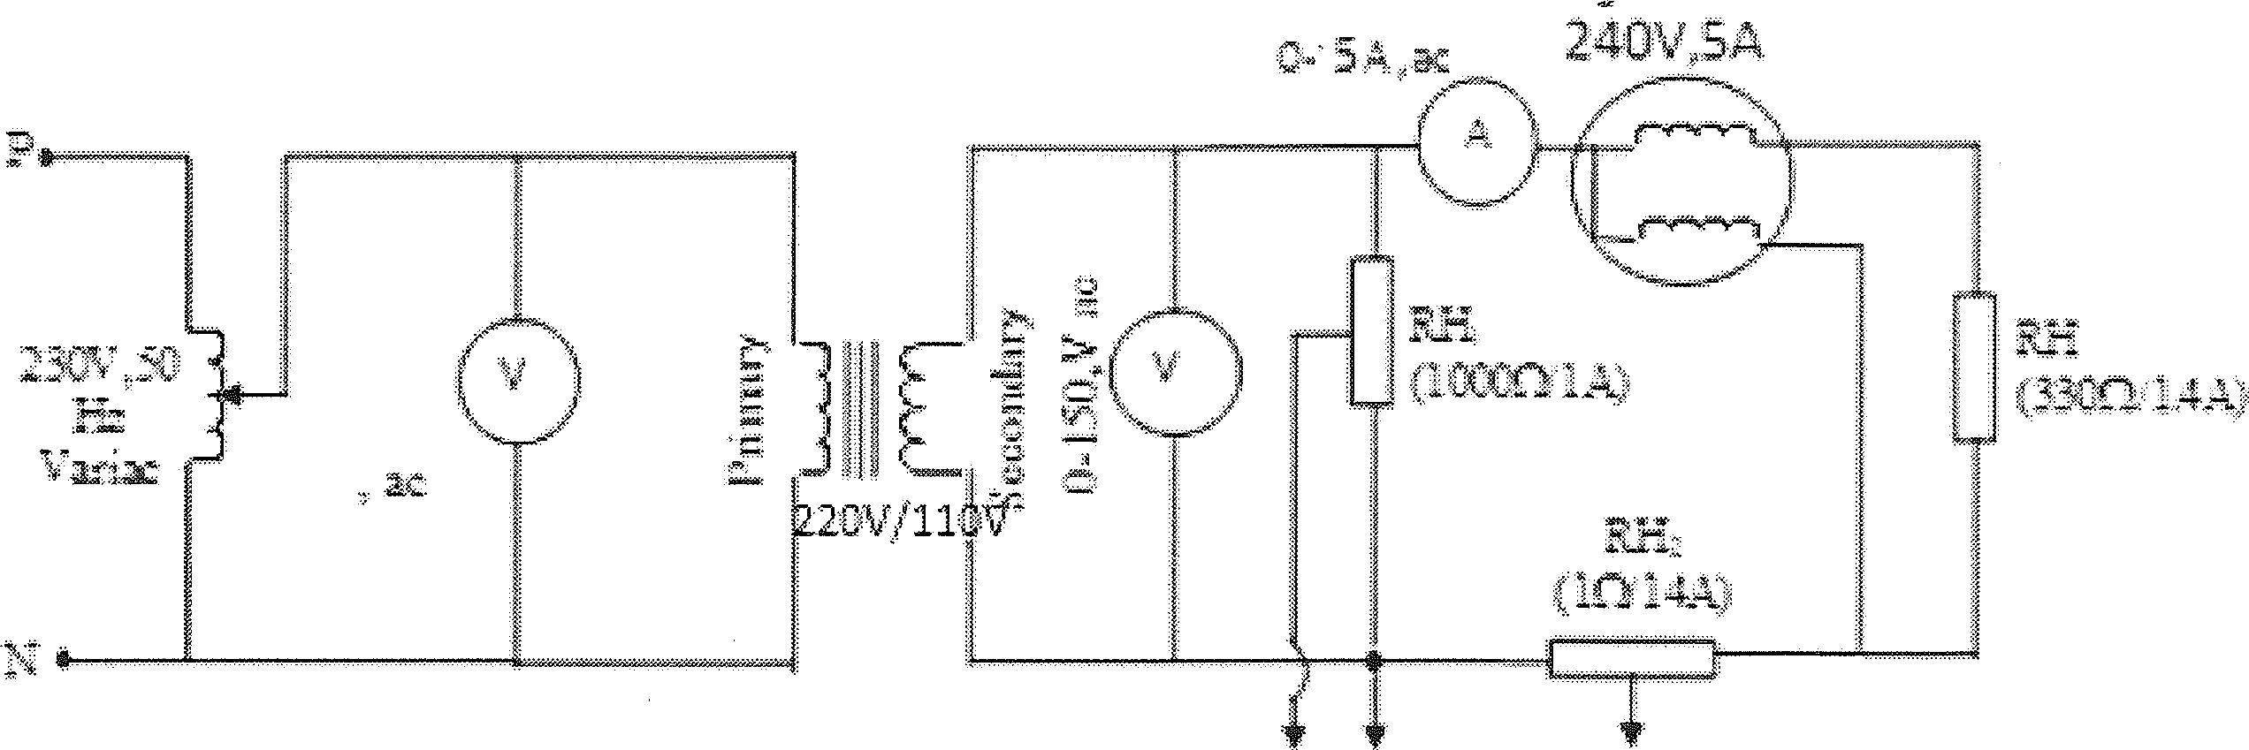

CH COM CH2

Figure 3. Circuit Diagram

1. Set the **Variac to zero position.**
2. Set the rheostat ‘RH1 and ‘RH2’ to the minimum position.
3. Show the circuit to the instructor in-charge of the experiment.
4. Turn on the oscilloscope.
5. Set the Time/DIV of the oscilloscope to 0.2 ms/DIV.
6. Set the Volts/DIV of CH1 Of oscilloscope to 1V/DIV.
7. Set the Volts/DIV of CH2 of oscilloscope to 1V/DIV.
8. Connect the input, as in Figure 3, to the supply.
9. Turns on the supply

1i. Increase the Variac voltage gradually until the secondary voltage is 110V.

1. Adjust the rheostats ‘RH1’ and ‘RH2’ slightly to get the full wave form on the oscilloscope screen.
2. Observe record the voltage and current waveforms
3. Record waveforms displayed on the screen of the oscilloscope.
4. Record the readings of wattmeter, ammeter and voltmeters

## Gradually reduce the Variac output until the primary voltage of the transformer

**is zero.**

## Turn off the supply.

1. **Disconnect the circuit input from the supply.**

# PART 02: RESISTIVE LOAD PARALLEL WITH INDUCTOIVE LOAD

* 1. Connect the circuit as shown in Figure 4

:-› ..„ -

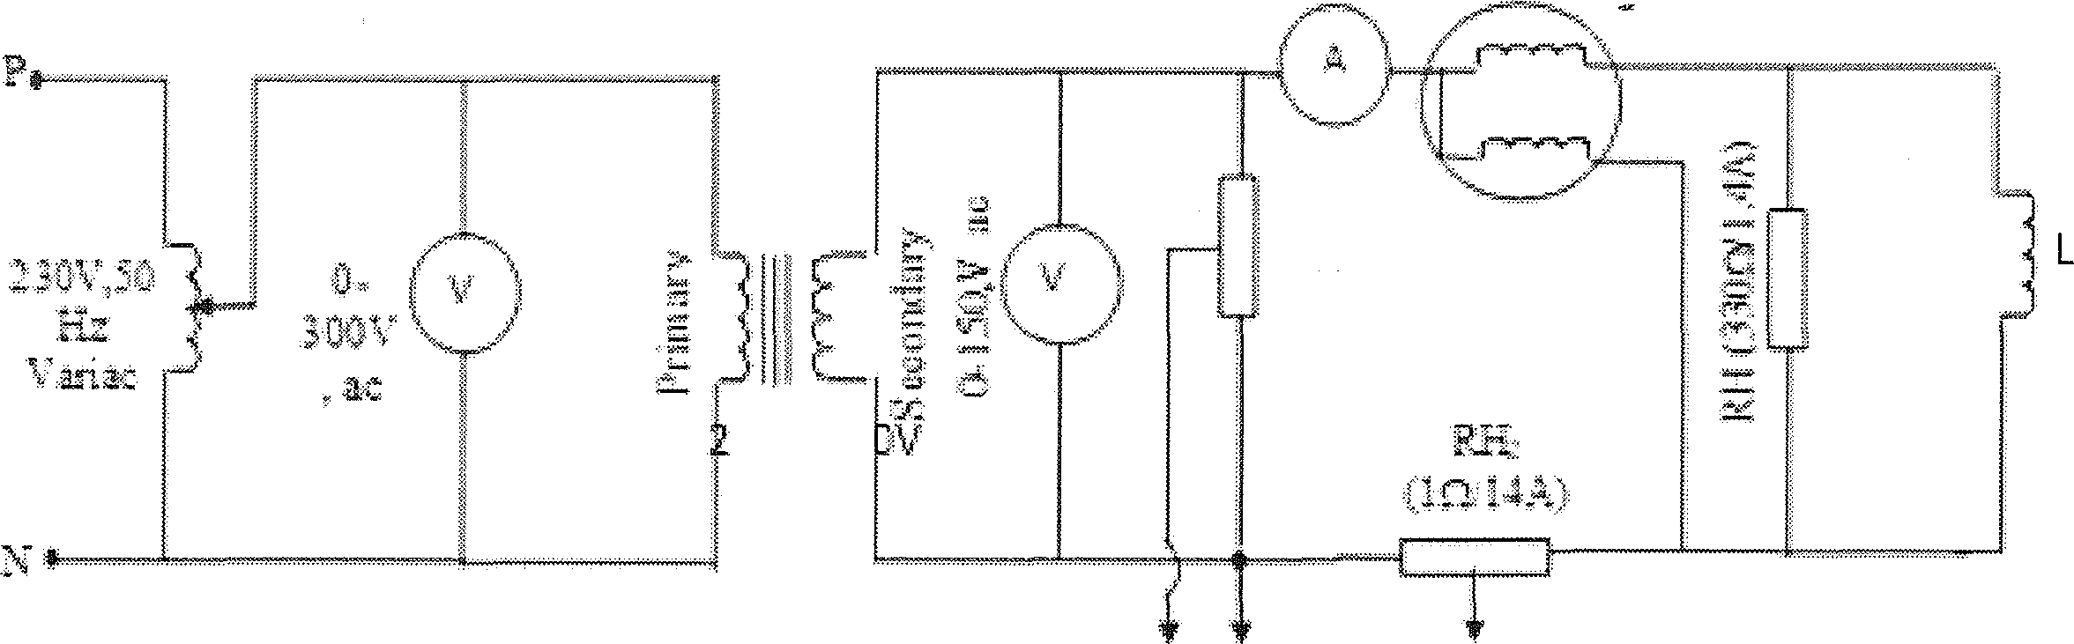

zev,’ii

“””

c- cv

Figure 4: Circuit Diagram

* 1. Set the **Variac to zero position.**
  2. Set the rheostat RH1, RH2 to the minimum position.
  3. Show the circuit to the instructor in-charge of the experiment.
  4. Turn on the oscilloscope.
  5. Set the Time/DIV of the oscilloscope to 0.5 ms/DIV.
  6. Set the Volts/DIV of CH1 of oscilloscope to IV/DIV.
  7. Set the Volts/DIV of CH2 of oscilloscope to 1V/DIV.
  8. Connect the input, as in Figure 4, to the supply.
  9. Turn on the supply

i1. Increase the Variac voltage gradually until the secondary voltage is 110V.

1. Adjust the Rheostats RH1 and RH2 slightly to get the voltage and total current full wave form on the oscilloscope screen. Observe and record the voltage wave form and total current waveform.
2. **Gradually reduce the Variac to zero position and power off the circuit.**
3. Connect the circuit as shown in Figure 05 Adjust the Rheostats RH1 and RH3 slightly to get the voltage and inductor current full wave form on the oscilloscope screen. Observe record the voltage waveform and current flowing through the inductor waveform.

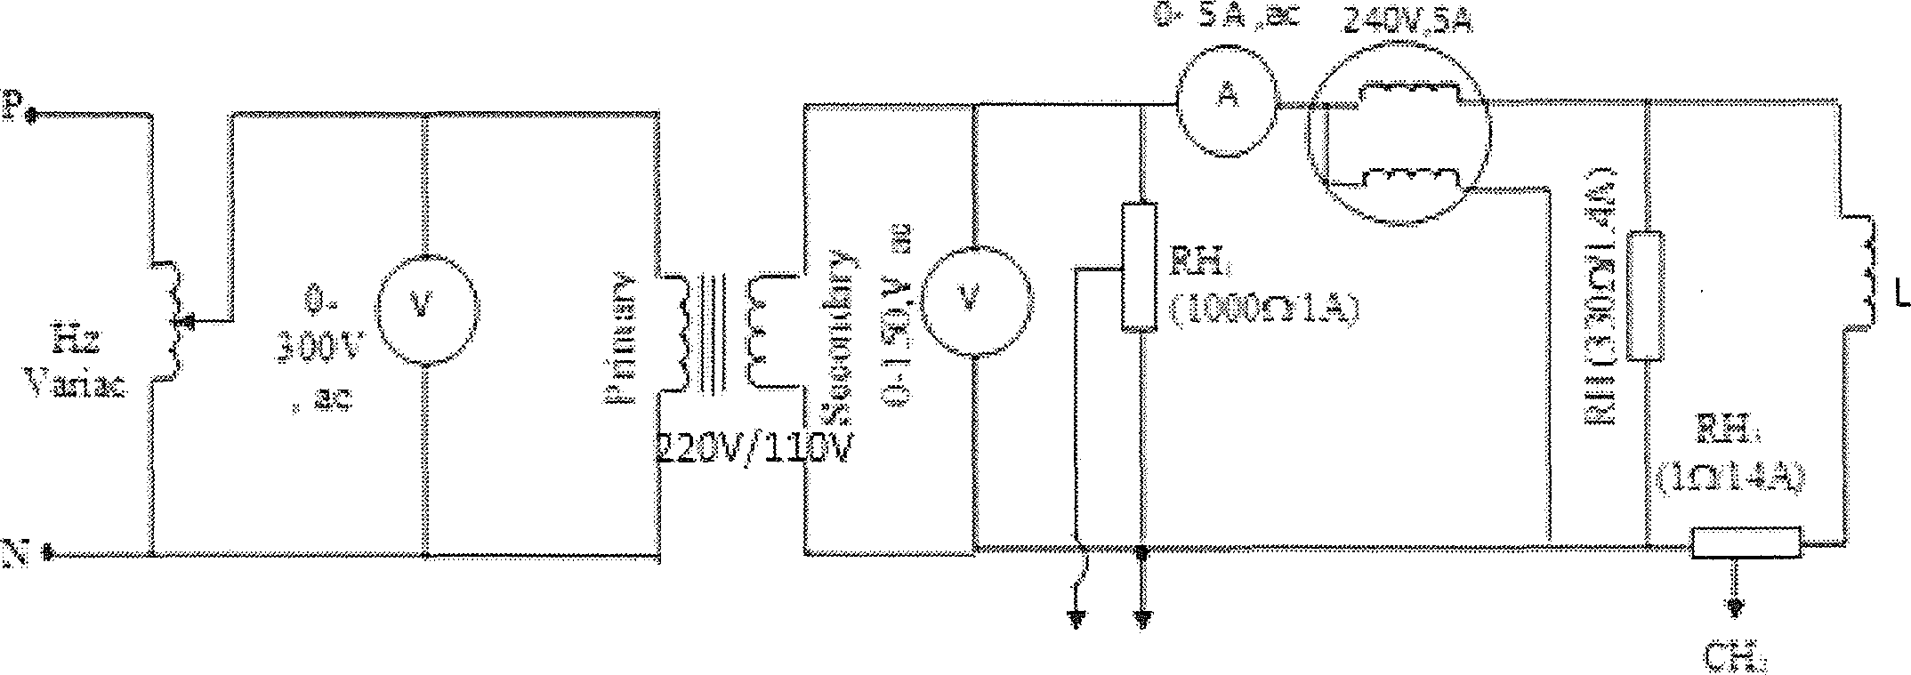

Figure 5: Circuit Diagram

1. Record the readings of wattmeter, ammeter and voltmeters
2. **Bring the primary voltage of the transformer to zero.**
3. **Turn off the supply.**
4. **Disconnect the circuit input from the supply.**

## PART 03: PARALLEL RLC (RESISTIVE, INDUCTIVEq CAPACITIVE) LOAD

1. Connect the circuit as shown in Figure 6

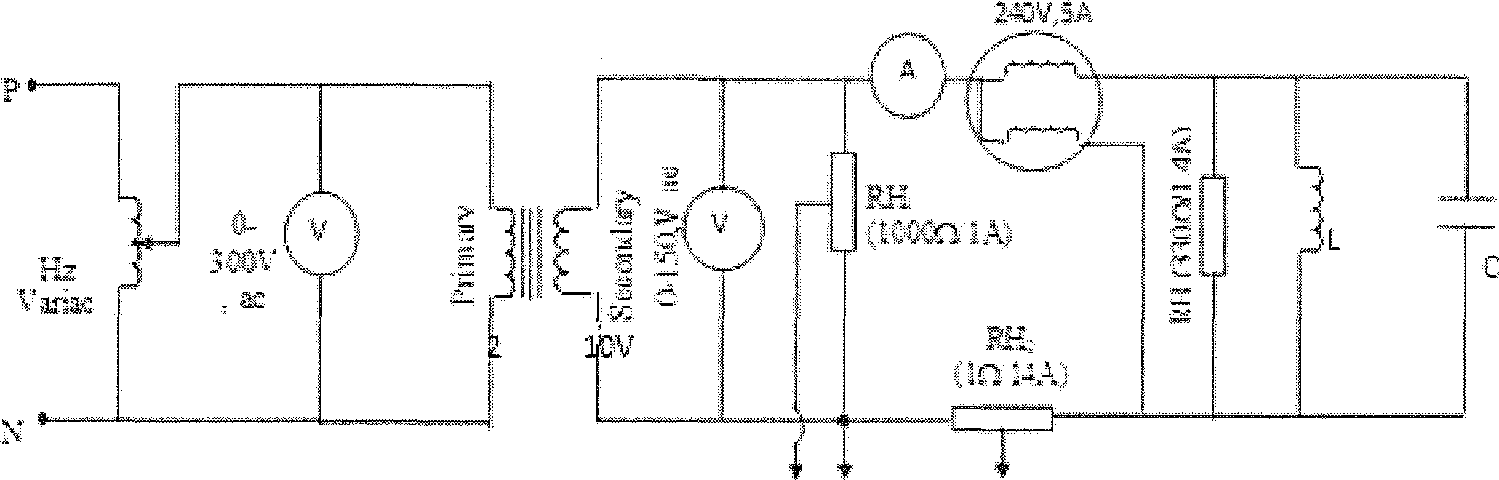

c

Figure 6: Circuit Diagram

z. Set the **Variac to zero position.**

1. Show the circuit to the instructor in-charge of the experiment.
2. Set the rheostat RHi and RHz to the minimum posltion.
3. Turn on the oscilloscope.
4. Set the Time/DIV of the oscilloscope to 0.5 ms/DIV.
5. Set the Volts/DIV of CHi of oscilloscope to IV/DIV.
6. Set the Volts/DIV of CH2 Of oscilloscope to 1V/DIV.
7. Connect the input, as iii Figure 6, to the supply.
8. Turn on the supply.

1i. Increase the Variac voltage gradually until the secondary voltage is 115V.

1. Adjust the Rheostats RHiand RHz slightly to get the voltage and total current full wave form on the oscilloscope screen. Observe and record the voltage wave form and total current waveform

## Gradually reduce the Variac position to zero and power off the circuit.

1. Connect the circuit as shown in Figure 7. Adjust the Rheostats RHi and RH3 slightly to get the voltage and capacitor current full wave form on the oscilloscope screen. Observe and record the voltage across the load waveform and current flowing through capacitor waveform.

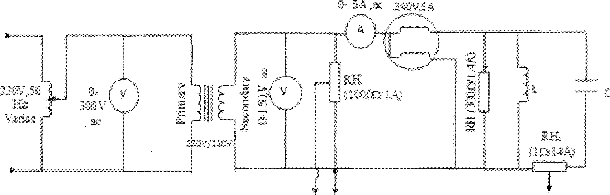

Figure 07: Circuit Diagram

1. Record the readings of wattmeter, ammeter and voltmeters.
2. Increase the capacitance in your circuit one step at a time. Note that the line current diminishes as capacitance is added. At some point, as you keep adding more capacitance the line current will start to increase. (The line current has gone through its minimum value). Minimum line current can be obtained graphically using the variation of the line current vs. capacitance.
3. **Bring the primary** voltage of **the transformer** to zero by **reducing** the Variac output voltage.
4. **Turn off the supply and disconnect the circuit input from** the supply.

# OBSERVATIONS:

**PART 01**

Voltage and Current Waveforms

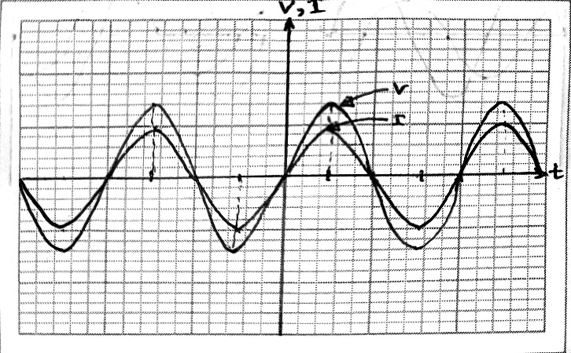

Figure 1: Voltage across the resistor and current flowing through the resistor Meter readings

|  |  |  |
| --- | --- | --- |
| Voltmeter reading/V | Ammeter Reading/A | Wattmeter reading/W |
| 110 | 0.32 | 34 |

# PART 02

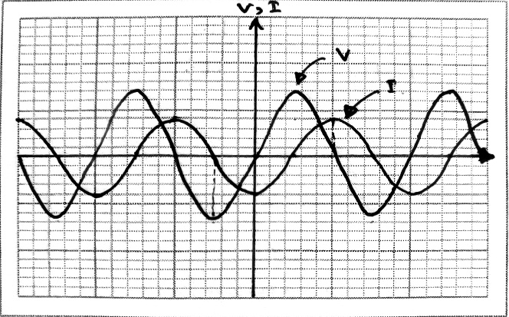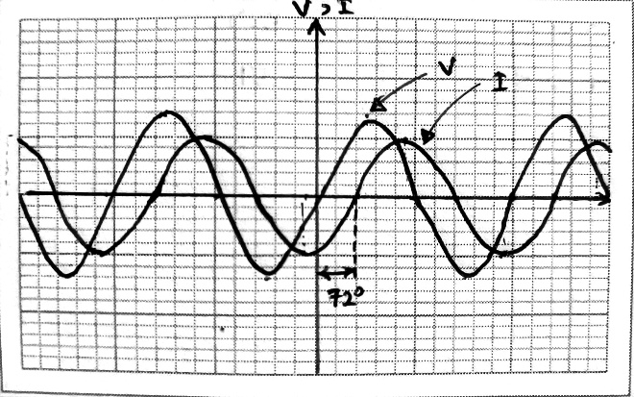

(a) Voltage and Total Current Waveforms (b) Voltage and Inductor Current Wave forms Figure 2: Voltages and currents of the system

Meter readings

|  |  |  |
| --- | --- | --- |
| Voltmeter reading/V | Ammeter Reading/A | Wattmeter reading/W |
| 110 | 1.02 | 40 |

# PART 03

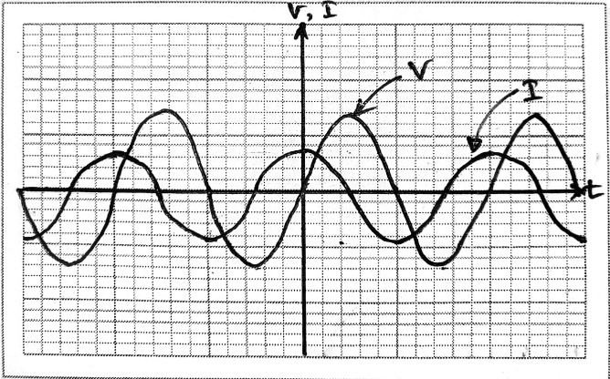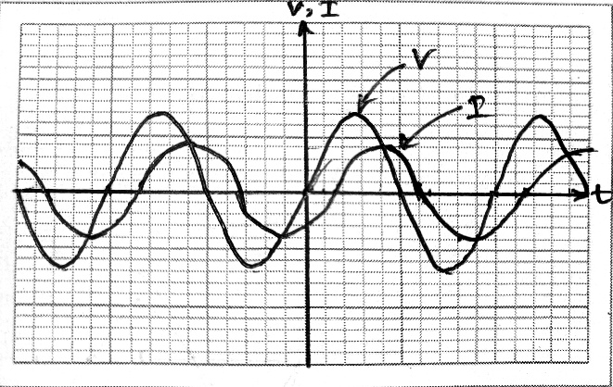

1. Voltage and Total Current Wave forms (b) Voltage and Capacitor Current Wave forms Figure 3: Voltages and currents of the system

Meter readings

|  |  |  |  |
| --- | --- | --- | --- |
| Capacitor  Value/μF | Voltmeter  reading/V | Ammeter Reading/A | Wattmeter reading/W |
| 9.90 | 115 | 0.76 | 42 |
| 19.95 | 115 | 0.50 | 44 |
| 29.50 | 115 | 0.48 | 46 |
| 37.90 | 115 | 0.64 | 47 |
| 47.90 | 115 | 0.96 | 50 |
| 57.90 | 115 | 1.28 | 51 |

# CALCULATIONS

**PART 02**

* 1. Calculate the power factor using meter readings

Power Factor = =

=

* 1. Calculate the power factor of the system using waveforms

Phase lag = 72°

Power Factor =

=

**PART 03**

1. Calculate the power factor using meter readings

Data set 1,

Data set 3,

Power Factor = =

=

Power Factor = =

=

1. Calculate the power factor of the system using waveforms

Phase lag = -140°

Power Factor =

=

1. Can you observe an improvement in the power factor compared to part2? Explain the reason

Compared Part 2, there is an improvement in power factor with the introduction of capacitive load into the system. Moreover, when the capacitance increased, phase difference reduced. Adding the capacitor in parallel to the system, compensates the lagging reactive power caused by the inductor. Therefore, the reactive part decrease and net power factor increase.

**DISCUSSION**

1. What is the purpose of using a transformer in the test set up?
2. Why the watt meter readings in Part 1 and Part 2 are different?
3. Explain the reason for wave form distortion, when a capacitive load is connected.